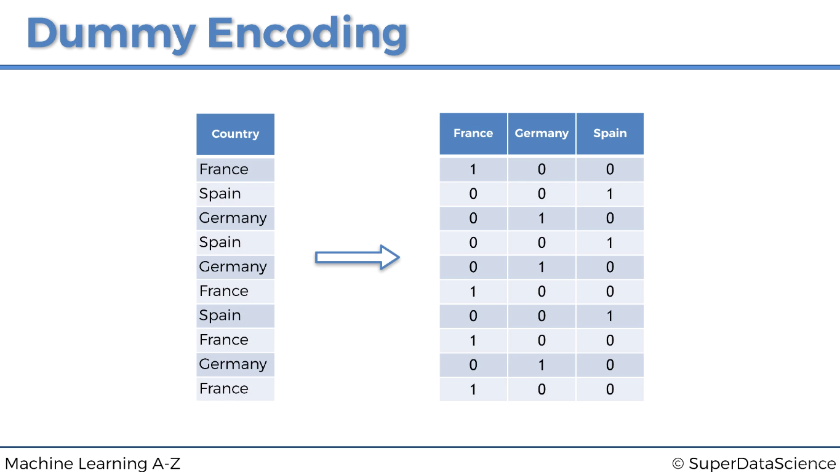We have three categories, so we create three columns (one for each variable) and give a binary combination. When France is there, it is 1 and the others are 0. Also for Germany and Spain.